##### A Project report on

###### NEWS I/O

###### A Dissertation submitted to JNTU Hyderabad in partial fulfillment of the academic requirements for the award of the degree.

**Bachelor of Technology**

**in**

**Computer Science and Engineering**

Submitted by

1. G. Kranthi Kumar 19H51A05N1
2. K.Vinay Bhargav 19H51A05N5
3. B. Hemanth 19H51A05M9

Under the esteemed guidance of

**Ms. A.Deepika**

(Assistant Professor)

**Department of Computer Science and Engineering**

**CMR COLLEGE OF ENGINEERING AND TECHNOLOGY**

(An Autonomous Institution under UGC & JNTUH, Approved by AICTE, Permanently Affiliated to JNTUH, Accredited by NBA.)

KANDLAKOYA, MEDCHAL ROAD, HYDERABAD - 501401.

#### 2019- 2023

**CMR COLLEGE OF ENGINEERING & TECHNOLOGY**

KANDLAKOYA, MEDCHAL ROAD, HYDERABAD – 501401

**DEPARTMENT OF COMPUTER SCIENCE AND ENGINEERING**

#### CERTIFICATE

This is to certify that the Mini Project-1 report entitled **"NEWS I/O"** being submitted by G. Kranthi Kumar **(19H51A05N1**), K.Vinay Bhargav **(19H51A05N5), B. Hemanth (19H51A05M9)**, in partial fulfillment for the award of **Bachelor of Technology in Computer Science and Engineering** is a record of Bonafide work carried out his/her under my guidance and supervision.

###### The results embody in this project report have not been submitted to any other University or Institute for the award of any Degree.

Ms. A.Deepika Dr. K Vijaya Kumar

Asst.Professor Professor and HOD

**Dept. Of CSE Dept. Of CSE**

Submitted for viva voice Examination held on ____________

**External Examiner**

**TABLE OF CONTENTS**

|  |  |  |  |
| --- | --- | --- | --- |
| **CHAPTER**  **NO.** | **TITLE** | | **PAGE NO.** |
|  | **LIST OF FIGURES** | | i |
|  | **LIST OF TABLES** | | ii |
|  | **ABSTRACT** | | iv |
| **1** | **INTRODUCTION** | | 1 |
|  | 1.1 | Need statement | 1 |
|  | 1.2 | Objective, Scope & Limitations | 1 |
|  |  | 1.2.1 Objective | 1 |
|  |  | 1.2.2 Scope | 2 |
|  |  | 1.2.3 Limitations | 2 |
| **2** | **BACKGROUND WORK** | | 3 |
|  | 2.1 | Introduction | 3 |
|  | 2.2 | Literature survey | 3 |
|  | 2.3 | Existing solutions | 4 |
| **3** | **PROPOSED SYSTEM** | | 7 |
|  | 3.1 | Introduction | 7 |
|  | 3.2 | Theoretical/ Conceptual framework | 7 |
|  |  | 3.2.1 Functional Requirements | 8 |
|  |  | 3.2.2 Non-functional Requirements | 8 |
|  |  | 3.2.3 Hardware Requirements | 8 |
|  |  | 3.2.4 Software Requirements | 9 |
|  | 3.3 | Advantages | 9 |
| **4** | **DESIGNING** | | 10 |
|  | 4.1 | Preliminary Design | 10 |
|  |  | 4.1.1 UML Diagrams | 10 |
|  |  |  |  |
| **5** | **RESULTS AND DISCUSSION** | |  |
|  | 5.1 | Implementation | 11 |
|  | 5.2 | Result | 14 |
| **6** | **CONCLUSION AND FUTUREWORK** | | 18 |
| **7** | **REFERENCES** | | 19 |

CMRCET B.Tech(CSE) PageNo i

## List of Figures

|  |  |  |  |
| --- | --- | --- | --- |
| **TABLE NO.** | **CHAPTER**  **NO.** | **TITLE** | **PAGE**  **NO.** |
| 1 | 3.2.2 | Theoretical/Conceptual Framework | 7 |
| 2 | 5.1.1 | Index.js | 11 |
| 3 | 5.1.2 | LayOut.css | 11 |
| 4 | 5.1.3 | LayOut.js | 12 |
| 5 | 5.1.4 | NewsSection.js | 13 |
| 6 | 5.2.1 | Desktop view | 14 |
| 7 | 5.2.2 | Mobile View | 15 |
|  |  |  |  |
|  |  |  |  |
|  |  |  |  |

CMRCET B. Tech (CSE) PageNo ii

# **List of Tables**

|  |  |  |  |
| --- | --- | --- | --- |
| **TABLE NO.** | **CHAPTER**  **NO.** | **TITLE** | **PAGE**  **NO.** |
| 1 | 4.1.1 | Use Case diagram | 10 |

CMRCET B. Tech (CSE) Page No iii

**ABSTRACT**

* The name of our project is NEWS I/O.
* It is a website that helps to know about the covid cases all over India.
* web app with 120+ news portals home page is with 3 trending sections
* It helps us know about the news which take place all over the world.
* disadvantages of existing models:

it do not have this much data no user friendly

CMRCET B. Tech (CSE) Page No iv

# **CHAPTER 1**

# **INTRODUCTION**

* The NEWS I/O is a WEB application that helps to keep an accurate record of

news which take place all over the world based on categories.

* In this website news is categorized into different ways.
* This NEWS I/O is a different from other news apps like it shows news which happens all over the world and also show top news based on the country.
* This website also have covid tracker so that we can track the covid cases from this website and be aware

## Need Statement

## It is observed that many users have to install apps if they want to communicate with others and sometimes mention their personal details while installing. An online web application can be introduced which can help in improving the security and easy to use even for the naive.

## 1.2 Objective, Scope & Limitation

## *1**.2.1 Objective*

* Objective: The main objective of our project is to display world wide news.
* It displays the top news of every country.
* We can choose the desired country we want the news about.
* It also has an additional feature based on the pandemic situation
* We can get information about COVID cases.
* We can also know the count about active COVID cases

CMRCET B.Tech (CSE) Page No 1

## *1.2.2 Scope*

## In future we can improve this website by adding sign in/login page.

## We can further add different languages, so that people can feel more comfortable to use it.

## We can recommend news according to user taste.

## *1.2.3 Limitations*

* We cannot update the news manually
* As it is a developer API news updates will be slow.
* API maintenance is required.

CMRCET B.Tech (CSE) Page No 2

**CHAPTER 2**

**BACKGROUND WORK**

## 2.1 Introduction

This section discusses findings and observations done by some research works on web-based chat room.

## 2.2 Literature survey

* React (also known as React.js or React JS) is a free and open-source front-end JavaScript library for building user interfaces based on UI components. It is maintained by Meta (formerly Facebook) and a community of individual developers and companies. React can be used as a base in the development of single-page or mobile applications. However, React is only concerned with state management and rendering that state to the DOM, so creating React applications usually requires the use of additional libraries for routing, as well as certain client-side functionality.
* **Node.js** is an [open-source](https://en.wikipedia.org/wiki/Open-source_software), [cross-platform](https://en.wikipedia.org/wiki/Cross-platform), [back-end](https://en.wikipedia.org/wiki/Front_end_and_back_end) [JavaScript](https://en.wikipedia.org/wiki/JavaScript) [runtime environment](https://en.wikipedia.org/wiki/Runtime_system) that runs on the [V8 engine](https://en.wikipedia.org/wiki/V8_(JavaScript_engine)) and executes JavaScript code outside a [web browser](https://en.wikipedia.org/wiki/Web_browser). Node.js lets developers use JavaScript to write command line tools and for [server-side scripting](https://en.wikipedia.org/wiki/Server-side_scripting)—running scripts server-side to produce [dynamic web page](https://en.wikipedia.org/wiki/Dynamic_web_page) content before the page is sent to the user's web browser. Consequently, Node.js represents a "JavaScript everywhere" paradigm,[[6]](https://en.wikipedia.org/wiki/Node.js#cite_note-6) unifying [web-application](https://en.wikipedia.org/wiki/Web_application) development around a single programming language, rather than different languages for server-side and client-side scripts.

CMRCET B. Tech (CSE) Page No 3

iii) **Sass** (short for ***syntactically awesome style sheets***) is a [preprocessor](https://en.wikipedia.org/wiki/Preprocessor" \o "Preprocessor) [scripting language](https://en.wikipedia.org/wiki/Scripting_language) that is [interpreted](https://en.wikipedia.org/wiki/Interpreted_language) or [compiled](https://en.wikipedia.org/wiki/Compiled_language) into [Cascading Style Sheets](https://en.wikipedia.org/wiki/Cascading_Style_Sheets) (CSS). SassScript is the scripting language itself.

Sass consists of two [syntaxes](https://en.wikipedia.org/wiki/Syntax_(programming_languages)). The original syntax, called "the indented syntax," uses a syntax similar to [Haml](https://en.wikipedia.org/wiki/Haml" \o "Haml).[[2]](https://en.wikipedia.org/wiki/Sass_(stylesheet_language)#cite_note-main-2) It uses [indentation](https://en.wikipedia.org/wiki/Indent_style) to separate [code blocks](https://en.wikipedia.org/wiki/Block_(programming)) and [newline](https://en.wikipedia.org/wiki/Newline) characters to separate rules. The newer syntax, "SCSS" (Sassy CSS), uses block formatting like that of CSS. It uses braces to denote code blocks and semicolons to separate rules within a block. The indented syntax and SCSS files are traditionally given the [extensions](https://en.wikipedia.org/wiki/Filename_extension) .sass and .scss, respectively.

**2.3 Existing solutions**

There are many existing web applications that offer live chatting opportunity and allow users to communicate. Every app has different features. A few existing solutions are:-

* **Alltop**
* **Panda**
* **Techmem**

CMRCET B. Tech (CSE) PageNo 4

**Alltop**

AllTop aggregates news and blog articles from the world’s most popular websites like TechCrunch, Mashable, BBC, CNN, and more. It curates and displays content in the real-time.

 Besides the most recent news, it has a viral category where it showcases the latest viral content and trends.

**Panda**

 Quite different from the above news aggregators, Panda aggregates content useful to web designers, developers, and tech entrepreneurs. It gathers content from Dribble, Behance, TechCrunch, Wired, and other similar **websites.**

CMRCET B. Tech (CSE) PageNo 5

**Techmeme**

* A brilliant technology-themed aggregator site that pulls in tech stories from all over the spectrum. It includes sites like Reddit alongside breaking business news.
* You’ll see that each article contains access to other sources, as well as the conversation happening on social. There’s a lot happening on the front page and there’s not much padding between the columns.

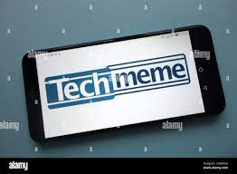

Disadvantages here…..

CMRCET B. Tech (CSE) Page No 6

**CHAPTER 3**

**PROPOSED SYSTEM**

## *3.1 Introduction*

This section presents the research methodology used in the study, the research design, and the data collection process.

*3.2 Theoretical/ Conceptual Framework*



Fig 3.2.2

The article explores the various steps in the process of providing news based reference, as well as issues involved in providing such service at each step. The purpose of this exploration is twofold: First, this article presents some open research questions at each step in the process of providing news -based reference service. Second, the entire process of providing News-based reference is viewed as a whole, and a model of the provision of news-based reference service is developed at a high level of abstraction. It is hoped that this model may serve as a conceptual framework for future discussions of and development of applications for news-based reference

CMRCET B. Tech (CSE) Page No 7

**Functional and Non-Functional Requirements**

**3.2.1 Functional Requirements**

The website should have simple interface with possibility to observe many news with small description in one page. Pushing link/button “read more” to see full information

The website should have tools to share the news in social requirement

## *3.2.2 Non-functional Requirements*

1.Usability

2.Availavility

3.Perfomance

## *3.2.3 Hardware Requirements*

**1** Laptop

2 Desktop

3 Smartphone

CMRCET B. Tech (CSE) Page No 8

## *3.2.4 Software Requirements*

* Software Requirements specifies the logical characteristics of each interface and software components of the system.HTML, CSS are used for the front end designing and JavaScript for client side and server-side validation.

## 3.3 ADVANTAGES

* The NEWS I/O keeps you updated and provides important educational value.
* It saves you time by gathering the news.
* It helps to open up your mind to new things and ideas.
* It make your way easy to know other country news.
* You Learn Of Things Going On In Your Community.

CMRCET B. Tech(CSE) PageNo 9

## CHAPTER 4

## DESIGNING

## 4.1 Preliminary design

Tools, which assist in preliminary design process, are UML Diagrams and ER diagrams

## *4.1.1 UML Diagrams*

1. Use-case Diagram:

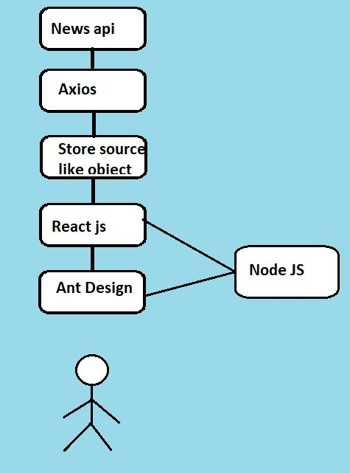

CMRCET B. Tech(CSE) PageNo 10

## CHAPTER 5: RESULTS AND DISCUSSION

**5.1 Implementation**

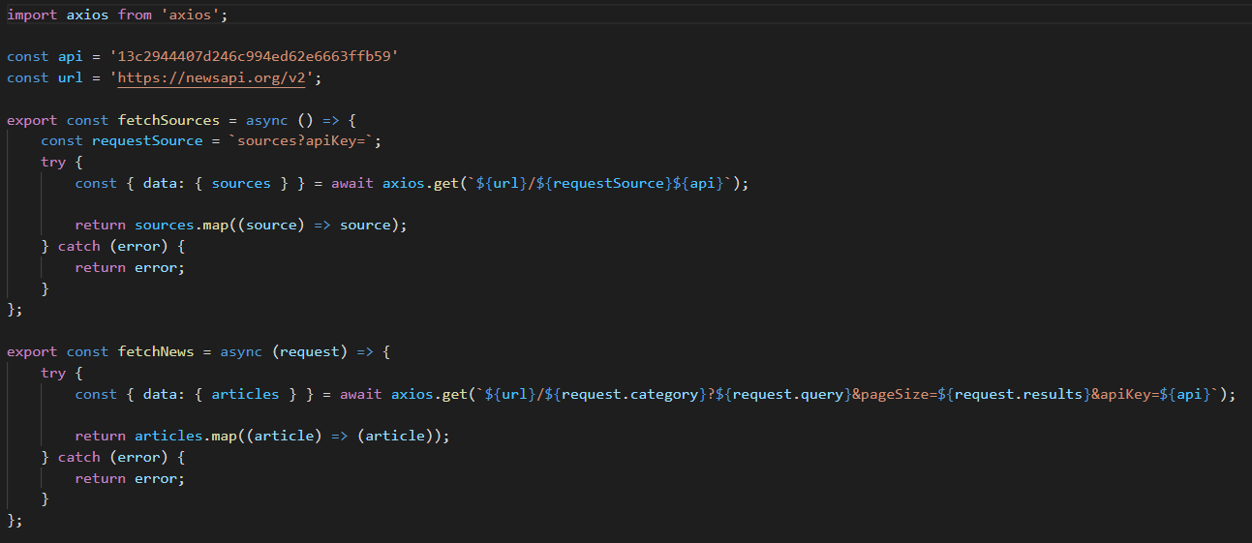

Fig 5.1.1 Index.js

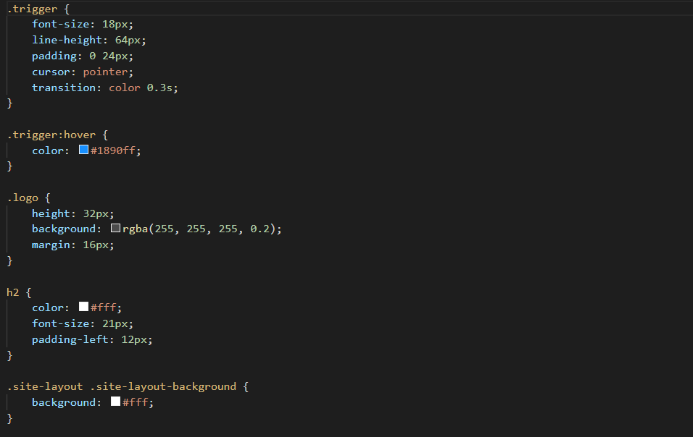

Fig 5.1.2 Layout.css

CMRCET B. Tech (CSE) Page No 11

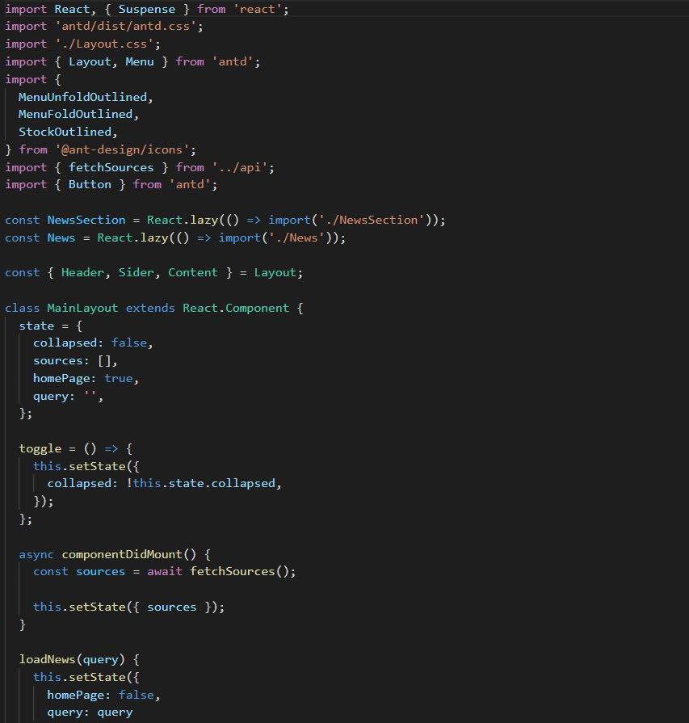

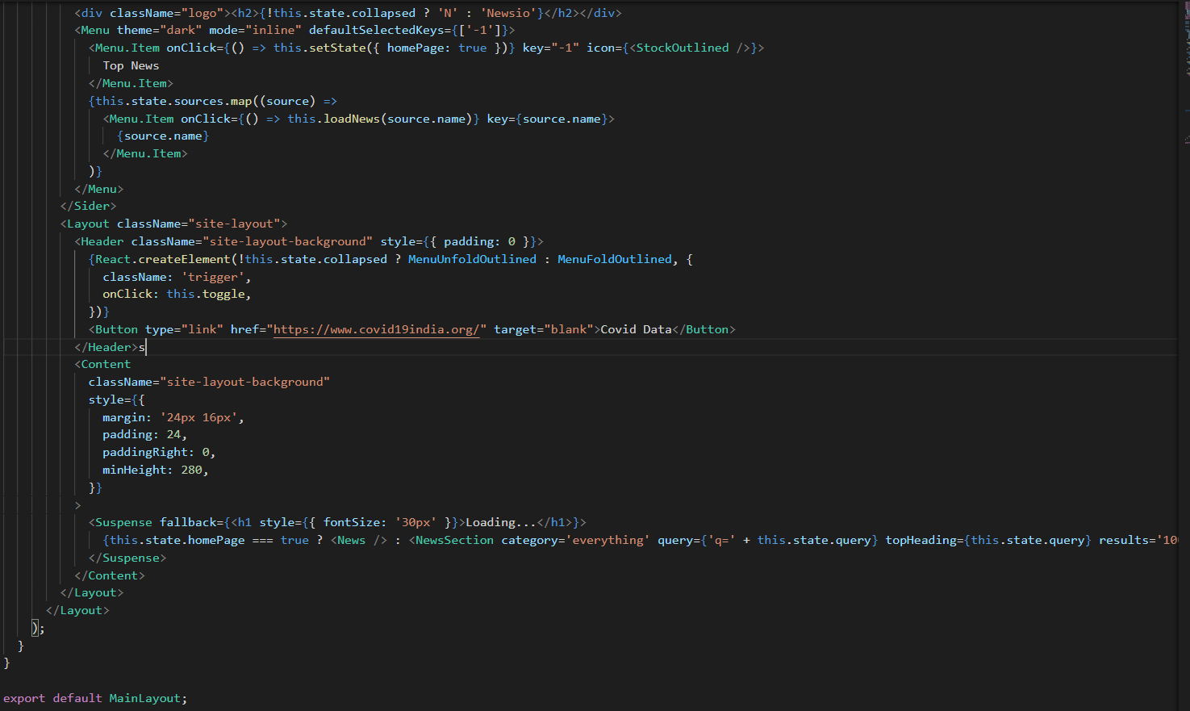Fig 5.1.3 LayOut.js

CMRCET B. Tech (CSE) Page No 12

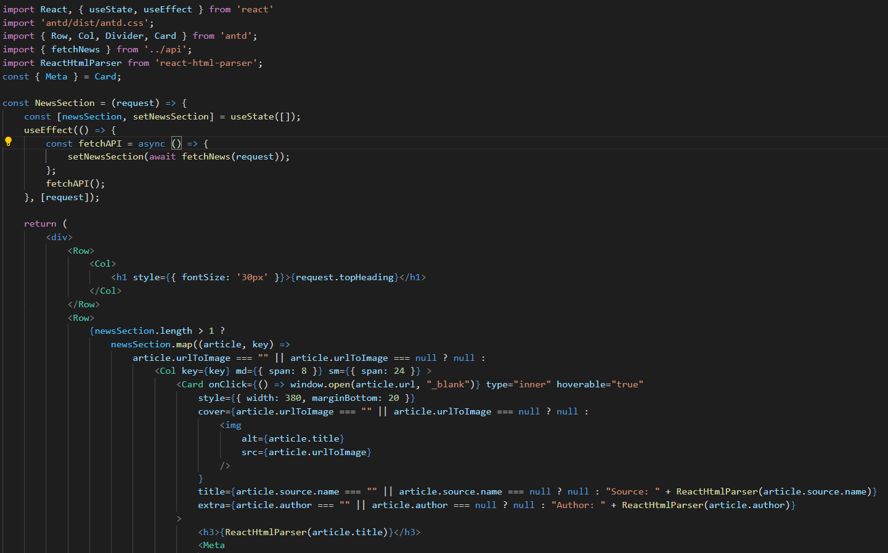

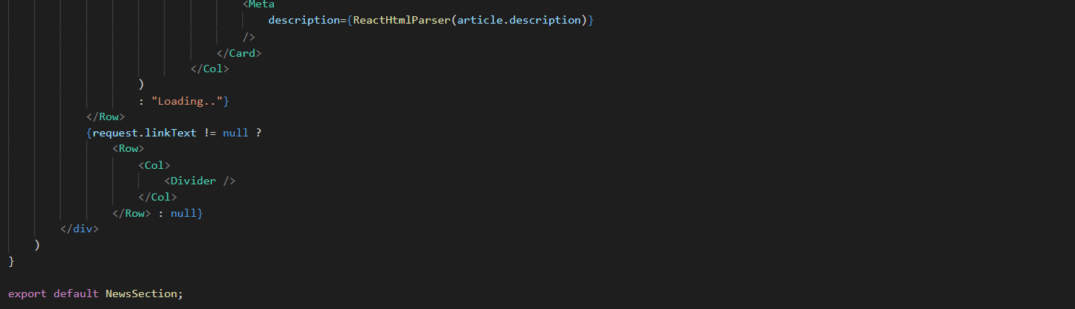

Fig 5.1.4 NewsSection.js

CMRCET B. Tech (CSE) Page No 13

**5.2 Result**

Fig 5.2.1 Desktop view



CMRCET B. Tech (CSE) Page No 14

Fig 5.2.1 Mobile view



CMRCET B. Tech (CSE) Page No 15

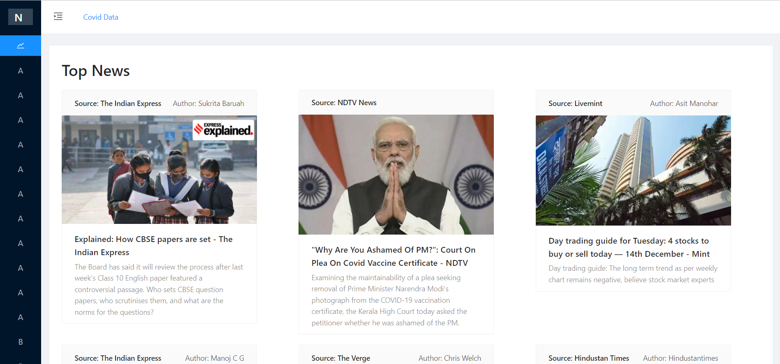

CMRCET B. Tech(CSE) PageNo 16

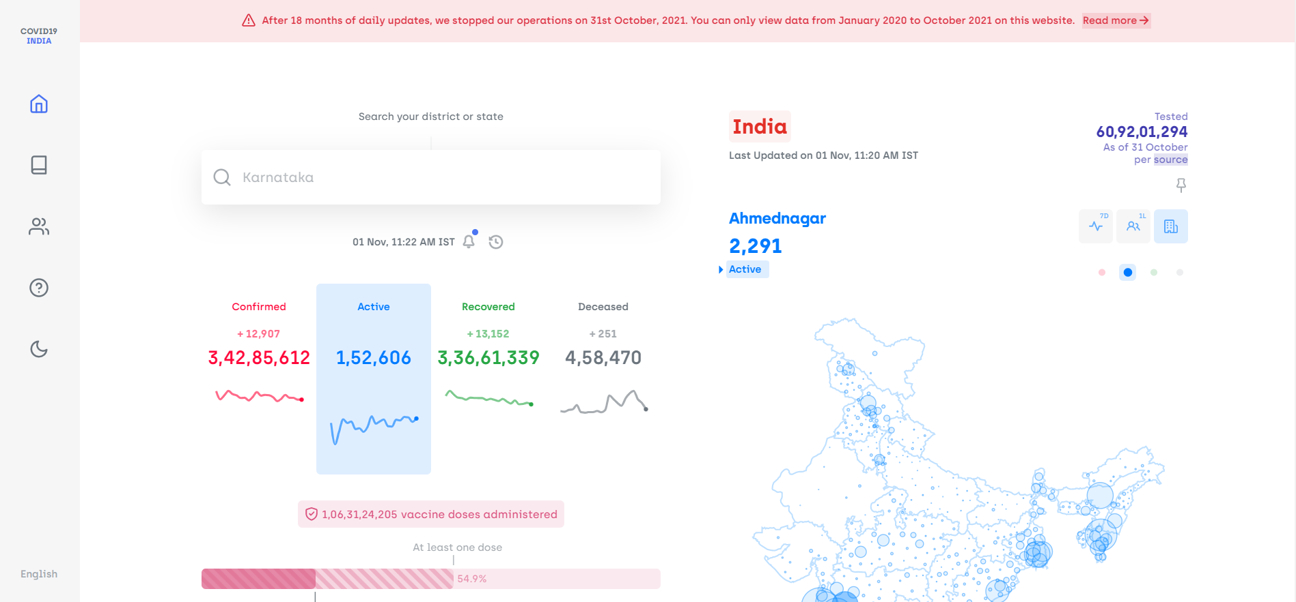

CMRCET B. Tech(CSE) PageNo 17

## CHAPTER 6

## CONCLUSION AND FUTURE WORK

### 6.1 Conclusions

The News app places a big focus on**images and quick-loading videos**, and publications such as The New York Times and National Geographic have partnered with the company to make their content readily available. You can also follow trends or individual topics, ranging from politics to niche topics

### 6.1 Future works

In the future we can add the following to our project:

* Login portal.
* Including AI and ML.
* News in different languages.

CMRCET B. Tech(CSE) PageNo 18

____________________________________________________________________

## REFERENCES

* <https://newsapi.org/>
* <https://www.covid19india.org/>
* <https://stackoverflow.com/>
* <https://github.com/kranthi0212/newsio>

CMRCET B. Tech(CSE) PageNo 19